Thinking and Learning

Through

Fairy Tales

In

Modern Foreign Languages


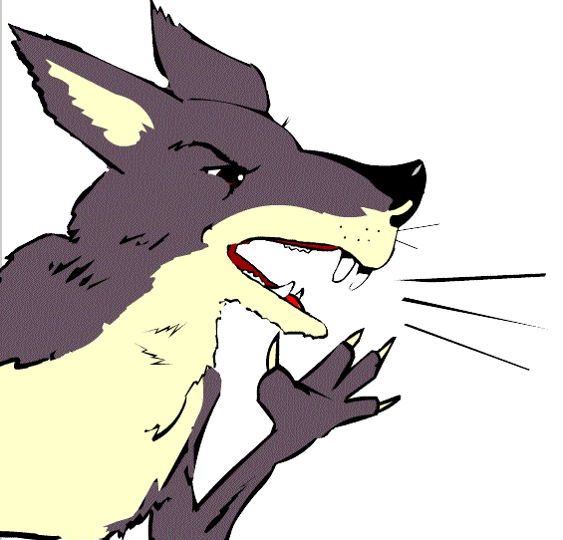


Contents

Card Sorting – Phonics | …………………………………. | 3 – 5
Story Boarding | …………………………………. | 6 – 7
Card Sorting – Nouns 1&2 | …………………………………. | 8 – 10
Map from Memory-Visual | …………………………………. | 11 – 15
Map from Memory-Auditory | …………………………………. | 16 – 17
Character Descriptions | …………………………………. | 18 – 20
Kim’s Game | …………………………………. | 21
Odd One Out | …………………………………. | 22 – 24
Dominoes | …………………………………. | 25 – 27
Pass the Parcel | …………………………………. | 28 – 30
Snakes and Ladders | …………………………………. | 31 – 33
Action Charades | …………………………………. | 34 – 36
Happy Families | …………………………………. | 37 – 41
Blockbusters | …………………………………. | 42 – 44
Narrative Format Script | …………………………………. | 45 – 47
Song  Board Game Language |  | 48  49
MFL KS2 Framework Y3 & 4 | …………………………………. | 50– 51

Card Sorting - Phonics

Purpose | - to sort, classify and group words  - to make connections  - to develop listening skills
Links to KS2 framework | - O3.1 Listen and respond to simple rhymes, stories and songs  - O3.2 Recognise and respond to sound patterns and words  - L3.1 Recognise some familiar words in written form  - L3.2 Make links between some phonemes, rhymes and spellings, and read aloud familiar words  - O4.2 Listen for specific words and phrases  - O4.3 Listen for sounds, rhyme and rhythm  - L4.2 Follow a short familiar text, listening and reading at the same time
Preparation | Pupils work in groups of 2 or 3. Each group will need:  - 1 phonic grid  - 1 set of phonic cards  It is advisable to use no more than 10 phonic words in any one session and to concentrate on just a few sounds at a time.
Activity | - Display phonic grid on power point or Smartboard and practise sounds. It is a good idea to introduce a beat or rhythm to assist recall. “We will rock you” by Queen is a good one.  - Give out set of 10 words. Say each word and ask groups to place in order in which you say them.  - Give out phonic grids.  - Now ask groups to sort the words by sounds placing each word in correct column of the grid.  - Ask groups to compare notes.  - Invite groups to feed back to whole class by listing words in one of the columns.  - Invite comment from other groups. Any uncertainties should be verified by listening to the animated version of the story.
Debrief | Ask pupils what they learned and found surprising about the language through the process. What skills did they use? I.e. listening, discussing, reasoning, etc.

St/st | ei | w | au | ü | sch

St/st | ei | w | au | ü | sch
Schweinestall | klein | wohnten | faul | für | schnell
Stroh | Schweinchen | weil | Haus | Tür | schönes
stabil | vorbei | wollte | Traum | brüllte | praktisch
husten | dein | Wolf | laut | Rülps | schmeckt
pusten | herein | antwortete | auf | Brühe | fantastisch
Backstein | heiße | weg | bauen | Glück | Schornstein
stelle | reicht | wieder | brauche |  | bisschen
kannst |  | Wasser |  |  | rutschte

Story Boarding

Purpose | - to develop sequencing skills  - to make deductions  - to make judgements informed by reasons and evidence  - to develop language learning strategies and knowledge about language
Links to KS2 framework | - O3.1 Listen and respond to simple rhymes, stories and songs  - O3.2 Recognise and respond to sound patterns and words  - L3.1 Recognise some familiar words in written form  - O4.2 Listen for specific words and phrases  - O4.3 Listen for sounds, rhyme and rhythm  - L4.2 Follow a short familiar text, listening and reading at the same time  - L4.3 Read some familiar words and phrases aloud and pronounce them accurately
Preparation | Pupils work in groups of 3 or 4. Each group will need:  - 1 set of picture cards
Activity | - Ask pupils to sequence the cards in the order in which they appear in the story.  - Using the animated on screen version ask class to find the German words for the pictures that appear on the first page. Ask them to explain their choice. Right or wrong, the reasons they give are very important as they are articulating language learning strategies. If word selected is incorrect ask class if there could be another word for the picture. Ask for reasons. Continue until correct word is identified.  - Once they have identified the words for the pictures that appear on the first page of the story, ask them to repeat the words after you. Ask them to comment on the sound and the spelling of the words – make links to phonic grid.  - Now ask them to listen to that page being read and to point to the pictures when they hear the words.  - Now remove the text and ask them to listen again to see if they can identify the words.  - Replay the first page with the text and ask them to try and join in when the word is said. Tell them that you intend to remove the text and would like them to still join in. Ask what they need to focus on to be able to do this.  Repeat for next few pages.
Debrief | Ask pupils what they discovered about language through the process and how they discovered it. What skills did they use? I.e. discussing, explaining, reasoning, justifying, making judgements etc.


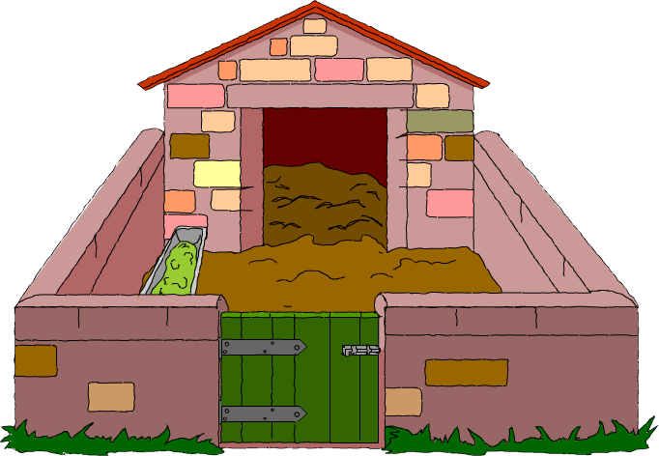
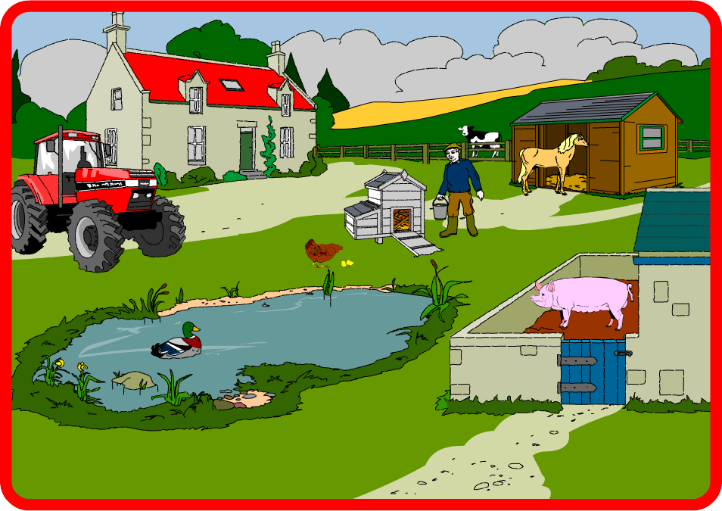
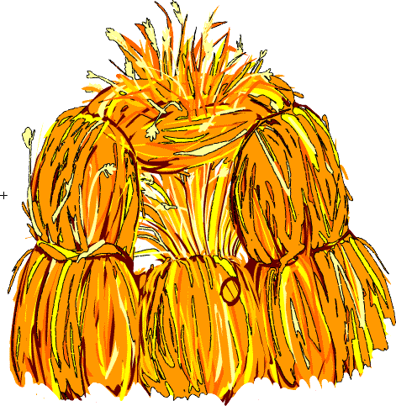
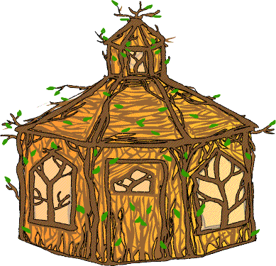
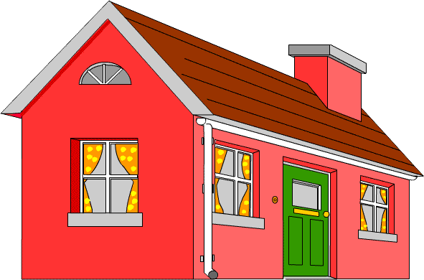
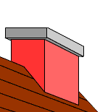





Card Sorting – Nouns 1

Purpose | - to sort, classify and group words  - to articulate precisely reasoning process  - to develop language learning strategies and knowledge about language
Links to KS2 framework | - O3.2 Recognise and respond to sound patterns and words  - L3.1 Recognise some familiar words in written form  - L3.3 Experiment with the writing of simple words  - O4.2 Listen for specific words and phrases  - L4.3 Read some familiar words and phrases aloud and pronounce them accurately
Preparation | Pupils work in groups of 3 or 4. Each group will need:  - 1 set of noun cards
Activity | - Give out the cards to each group. Say the words on each card and ask pupils to put them into the sequence as you say them. Discuss any that were difficult to identify.  - Ask pupils to sort the cards into groups.  - After 5 minutes ask each group how they chose to sort.  - Whatever way groups have sorted the words go in that direction. For example if a group has sorted into words they know and don’t know, check the meaning of the words that they think they know in the story. Listen to the pronunciation of the words and practice repeating them.  - Now look in the story to work out the meaning of the group of words they didn’t know. Listen to the sounds of the new words and practice the pronunciation. Relate to phonic grid.  - If they still can’t work out the meaning what other strategies do they think they could employ?  - Ask them to choose a favourite word and to draw it in the air on the back of their partner. In pairs or groups try and guess each other’s favourite word.
Debrief | Ask pupils what they discovered about language through the process and how they discovered it. What skills did they use? I.e. discussing, explaining, reasoning, deducing, justifying etc.

Card Sorting – Nouns 2

Purpose | - to sort, classify and group words  - to articulate precisely reasoning process  - to make links between words  - to develop language learning strategies and knowledge about language
Links to KS2 framework | - O3.2 Recognise and respond to sound patterns and words  - L3.1 Recognise some familiar words in written form  - L3.3 Experiment with the writing of simple words  - O4.2 Listen for specific words and phrases  - L4.3 Read some familiar words and phrases aloud and pronounce them accurately
Preparation | Pupils work in groups of 3 or 4. Each group will need:  - 1 set of noun cards
Activity | - Give out the cards to each group. Say the words on each card and ask them to put them into the sequence as you say them. Discuss any that were difficult to identify.  - Ask pupils to sort the cards into groups.  - After 5 minutes ask each group how they chose to sort.  - Whatever way groups have sorted the words go in that direction.  - Some groups will probably sort by “der”, “die” and “das”. Ask pupils to explain what the “der”, “die” and “das” could mean and consequently to articulate precisely how they have sorted – i.e. by gender.  - Confirm their understanding by checking in the story. Gender is a difficult concept for English speakers, give pupils time to reflect on the concept.  - Ask other groups to comment.
Debrief | Ask pupils what they discovered about language through the process and how they discovered it. What skills did they use? I.e. discussing, explaining, reasoning, deducing, justifying etc.

das Schweinchen | der Schweinestall | der Bauernhof | das Strohhaus
der Wolf | das Holzhaus | das Backsteinhaus | der Schornstein
der Topf | die Karotten | die Zwiebeln | das Feuer

Map from Memory – Visual

Purpose | - to interpret and organise information  - to make links between words  - to look for patterns  - to develop memory strategies
Links to KS2 framework | - L3.1 Recognise some familiar words in written form  - L3.3 Experiment with the writing of simple words  - L4.1 Read and understand a range of familiar written phrases  - L4.4 Write simple words and phrases using a model and some words from memory
Preparation | Pupils work in groups of 3 or 4. Each group will need:  - A blank map  - One set of visuals (pictures and words)
Activity | - Tell pupils that there is one copy of the “map” and that they have to reproduce it, as a group, as accurately as possible.  - One member of each group comes to look at the map one at a time for 15 seconds.  - Pupils then go back to their groups and record what they can remember onto their blank map.  - Repeat above two stages for each member of the group and for as many times as you deem necessary.  - When the time is up ask groups to wander around and look at the maps produced by other groups.  - Reveal original map on power point. Ask for feedback on the activity.
Debrief | Ask pupils what strategies they employed to carry out the task. Ask them  - what they did well  - what they could do better  - what they would do differently if they were to do the activity again  What skills did they use? I.e. discussing, collaboration, listening, planning, explaining, reasoning, justifying etc.

ein Huhn
ein Pferd
eine Kuh
ein Schwein
der große rote Traktor
der Bauer
ein rotes Dach
eine große graue Wolke
die Scheune
der Ententeich
eine Ente
Ein großer Bauernhof
der Schweinestall

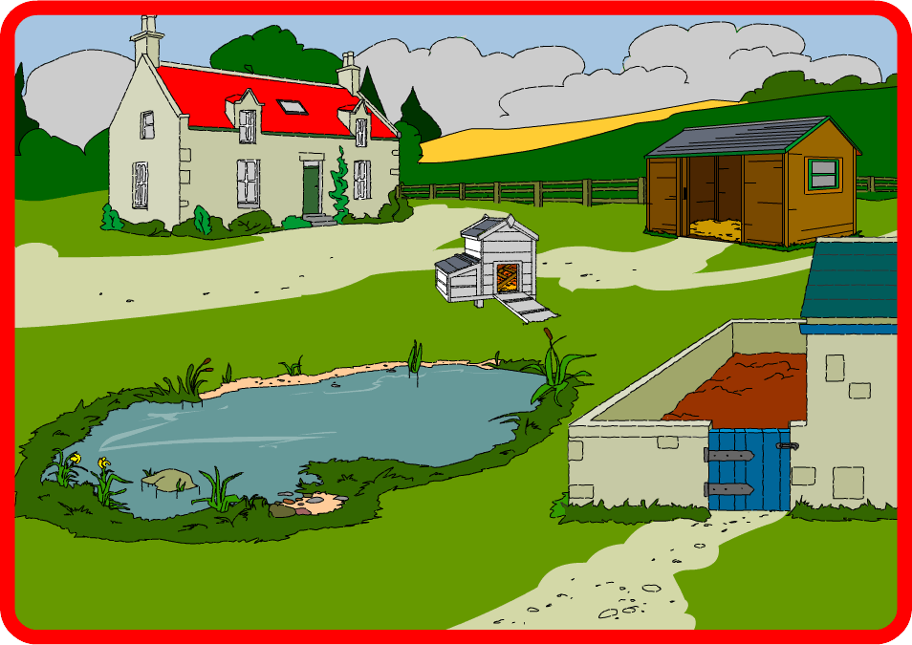
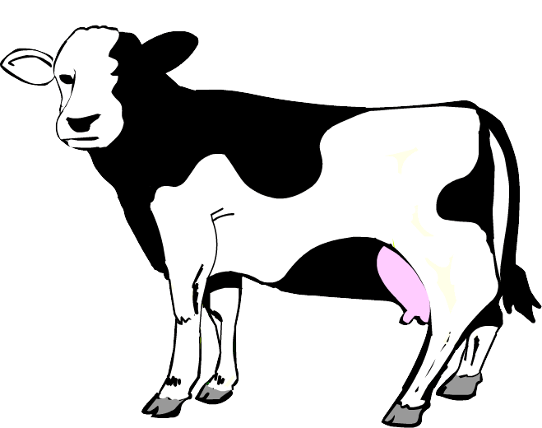
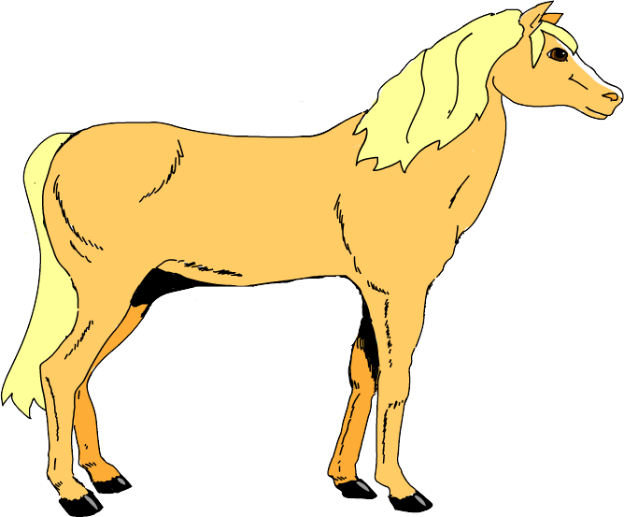
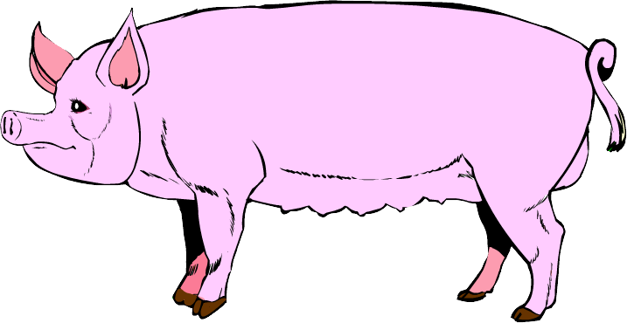
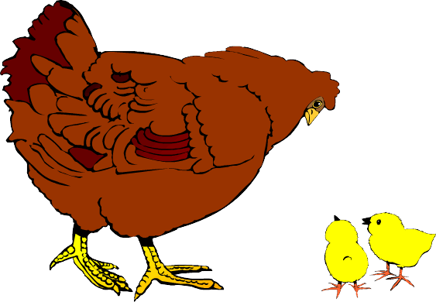

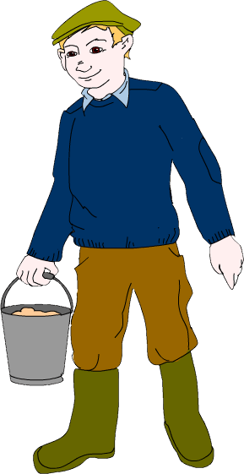

Ein großer Bauernhof | Ein großer Bauernhof | Ein großer Bauernhof | Ein großer Bauernhof
der Ententeich | der Ententeich | der Ententeich | der Ententeich
die Scheune | die Scheune | die Scheune | die Scheune
eine große graue Wolke | eine große graue Wolke | eine große graue Wolke | eine große graue Wolke
ein rotes Dach | ein rotes Dach | ein rotes Dach | ein rotes Dach
der Schweinestall | der Schweinestall | der Schweinestall | der Schweinestall
eine Ente | eine Ente | eine Ente | eine Ente

Map from Memory – Auditory

Purpose | - to interpret and organise information  - to develop memory strategies  - to develop listening skills
Links to KS2 framework | - O3.2 Recognise and respond to sound patterns and words  - O3.4 Listen attentively and understand instructions, everyday classroom language and praise words  - L3.1 Recognise some familiar words in written form  - L3.2 Make links between some phonemes, rhymes and spellings, and read aloud familiar words  - O4.2 Listen for specific words and phrases  - O4.3 Listen for sounds, rhyme and rhythm  - L4.1 Read and understand a range of familiar written phrases  - L4.3 Read some familiar words and phrases aloud and pronounce them accurately
Preparation | Pupils work in groups of 3 or 4. Each group will need:  - 1 set of phrase cards
Activity | - Give one set of cards to each group of pupils. Read the phrases aloud and ask pupils to sequence in the order in which they hear them.  - Now ask pupils to set cards upside down on the table.  - Each pupil takes it in turns to turn up a card and to read it aloud in German.  - Ask the groups to look at the phonics in the words on the cards.  - Explain that one person from each group will come and hear the phrases being read through once.  - They will return to their group and begin the process of sequencing the phrases in the order in which they were read.  - Each member of the group has an opportunity to come out and listen to the phrases.  ( Any page from the story can be used for this activity)
Debrief | Ask pupils what strategies they employed to carry out the task. Ask them  - what they did well  - what they could do better  - what they would do differently if they were to do the activity again  What skills did they use? I.e. discussing, collaboration, listening, planning, explaining, reasoning, justifying etc.

Also baute sich | Schweinchen Doof
ein Haus | aus Backsteinen.
Das Haus | war groß
und sehr stabil. | „Fantastisch,
nicht wahr! | Vielleicht bin ich
doch nicht | so doof!”
dachte er.

Character Descriptions

Purpose | - to develop listening skills  - to interpret and organise information  - to make links between pieces of information  - to articulate precisely the reasoning process  - to develop language learning and knowledge about language strategies
Links to KS2 framework | - O3.2 Recognise and respond to sound patterns and words  - O3.4 Listen attentively and understand instructions, everyday classroom language and praise words  - L3.1 Recognise some familiar words in written form  - L3.2 Make links between some phonemes, rhymes and spellings and read aloud familiar words  - O4.2 Listen for specific words and phrases  - L4.1 Read and understand a range of familiar written phrases  - L4.2 Follow a short familiar text, listening and reading at the same time  - L4.3 Read some familiar words and phrases aloud and pronounce them accurately
Preparation | Pupils work in groups of 3 or 4. Each group will need:  - 1 set of phrase cards  - a large speech bubble for each of the four characters might be helpful
Activity | - Give one set of cards to each group of pupils. Read the phrases aloud and ask pupils to sequence in the order in which they hear them.  - Ask pupils to repeat the phrases  - Ask pupils to sort the cards into groups.  - After 5 minutes ask each group how they chose to sort.  - Whatever ways the groups have sorted go in that direction. Groups may have sorted by phrases they know and don’t know or ones starting with ‘ich bin’, or to do with houses, speech or characters etc.  - What other strategies do they think they could employ to work out phrases they don’t know?  - Ask each group to sort the cards to match the characters in the story.  - Ask each group to feed back by describing a character and explaining its decisions.  - Phrases could also be sorted into characteristics, speech, and actions and could also be used for role-play/puppet dialogues.
Debrief | Ask pupils how they came to an agreement on how to sort their cards. What skills did they use? I.e. listening, discussing, explaining, reasoning, justifying etc.

Ich wohne in einem schönen Schweinestall. | Ich baute mir ein Haus aus Stroh. | Ich dachte, „ Ich baue mir ein Haus aus Stroh.”
Ich war lecker. | Ich baute mir ein Haus aus Holz. | Ich sagte, „Das fällt mir ja im Traum nicht ein !”
Ich bin faul. | Ich baute mir ein Haus aus Backsteinen. | Ich bin groβ und böse.
Ich bin schick. | Früh an einem Morgen verlieβ ich den Biobauernhof. | Woraus soll ich mir ein Haus bauen ?
Ich bin doof. | Ich habe eine gute Idee. | Ich hustete und pustete.
Ich bin klein. | Ich kochte eine gute Suppe zum Abendessen. | Ich fiel ins heiße Wasser.

Ich brauchte Karotten. | Mein Haus wurde weggeblasen. | Ich sagte, „Schnell ! Heraus da !”
Rotkäppchen ist meine Freundin. | Der Wolf mochte meine Suppe. | Ich sagte, „Schweinchen klein, lass mich herein !”
Mein Haus ist sehr praktisch. | Ich stellte den Topf auf das Feuer. | Mein Haus blieb stehen.
Mein Haus ist groβ und stabil. | Ich trage eine Sonnenbrille. | Ich klopfte sehr laut an die Tür.
Ich wohne auf dem Lande. | Ich mochte die Suppe. | Ich rief, „ich werde husten und pusten.”
Mein Haus ist sehr elegant. | Ich rutschte den Schornstein herunter. | Ich fraβ zwei Schweinchen auf.

Kim’s Game

Purpose | - to identify strategies for memorising
Links to KS2 framework | - O3.2 Recognise and respond to sound patterns and words  - O4.3 Listen for specific words and phrases
Preparation | A basket containing about 10 items relating to the fairy tale. These could be:  a pig a brick a spider  a rabbit some straw a wolf  a carrot some wood a snail  an onion a cow a squirrel  a house a sheep a pan
Activity | - Tell pupils that you are going to place some items on the table and then cover them up.  - Tell class that you would like them to try and remember the objects.  - Take out the objects one at a time. It can be useful to say the name of the object, and add an appropriate action before placing it on the table. This often becomes part of the memorisation process for different types of learners.  - Give about 30 seconds for looking at all the objects together on the table, then cover up or put away.  - Give pupils about a minute to recall as many objects as possible. Note: do not tell them how this should be done. They often assume that it must be done alone – if they choose to work with someone else do not stop them.
Debrief | Ask pupils what strategies they used to remember the objects. Write the various strategies on the board. Discuss the nature of the different strategies and what it would be like to adopt a different one.

Odd One Out

Purpose | - to identify similarities and differences  - to promote understanding of properties and attributes of words  - to develop reasoning skills and knowledge about language
Links to KS2 framework | - O3.2 Recognise and respond to sound patterns and words  - L3.1 Recognise some familiar words in written form  - L3.2 Make links between some phonemes, rhymes and spellings, and read aloud familiar words  - L3.2 Experiment with the writing of simple words  - L4.3 Read some familiar words and phrases aloud and pronounce them accurately
Preparation | Pupils work in groups of 2 or 3. Each group will need:  - 1 odd one out grid
Activity | - Read out the words in each column for number 1. Ask pupils to repeat.  - Ask pupils to choose an odd one out and to explain their choice (say why…). Emphasise that there are no right or wrong answers, but that all answers must be explained.  - Ask them to write down their explanation in English.  - Repeat for each numbered line.  - Ask one group to read out words in one of the lines from the power point. Ask them to feed back on their choice of Odd One Out.  - Ask other groups for comments.  - Repeat the process for the other lines.  - When all the lines are completed ask groups to make up their own odd one outs using words or phrases from the story.
Debrief | Ask pupils what knowledge about language they discovered during the activity. Ask them how they discovered it. What skills did they use? I.e. discussing, explaining, reasoning, justifying etc.

Was gehört nicht dazu?

Unterstreich in jeder Gruppe das nicht dazugehörige Wort und gib einen Grund dafür?

 | A | B | C | D |  | WARUM?
1 | Bauernhof | Schweinestall | Stroh | Haus

2 | faul | doof | leise | böse

3 | Stroh | Schornstein | Backstein | Holz

4 | probieren | praktisch | Platsch | vegetarisch

5 | rutschte | kletterte | dachte | sprang

6 | Schweinchen | Wolf | Kaninchen | Rotkäppchen

7 | lecker | leise | schnell | laut

Jetzt bist du dran!

 | A | B | C | D |  | WARUM?
1

2

3

4

Dominoes

Purpose | - to sort words  - to make connections  - to develop memory skills
Links to KS2 framework | - O3.2 Recognise and respond to sound patterns and words  - O3.3 Perform simple communicative tasks using single words, phrases and short sentences  - L3.1 Recognise some familiar words in written form  - L3.2 Make links between some phonemes, rhymes and spellings, and read aloud familiar words  - O4.2 Listen for specific words and phrases  - O4.3 Listen for sounds, rhyme and rhythm  - L4.2 Follow a short familiar text, listening and reading at the same time  - L4.3 Read some familiar words and phrases aloud and pronounce them accurately
Preparation | Pupils work in groups of 3. Each group will need:  - 1 set of dominoes
Activity | - ask the class to distribute the dominoes equally among group members  - pupil with * * * places his card on the table saying the German word aloud  - continue as a game of dominoes ensuring that the German words are said aloud.  - Continue until final * * * card is laid
Debrief | Ask pupils what skills they employed during the game. i.e. listening, memorising, reasoning. Ask if they learned any new words. How did they learn them?

***  3 Schweinchen | straw | Zwiebeln | water | ein Feuer | to knock
der Topf | onions | Backstein | delicious | bauen | door
Kaninchen | a fire | Bauernhof | wood | klopfen | in the  country
Wasser | bad | lecker | chimney | eine Tür | farm
laut | idea | Stroh | lazy | faul | to build

auf dem Lande | brick | böse | quietly | kochen | early
Holz | rabbit | Suppe | loudly | früh | practical
leise | soup | Schornstein | carrots | praktisch | to taste
husten und pusten | das Ende  **** | Karotten | easy | probieren | to visit
leicht | the pot | Idee | to cook | besuchen | huff and puff

Pass the Parcel

Purpose | - to sort, classify and sequence words  - to make connections  - to make predictions
Links to KS2 framework | - O3.1 Listen and respond to simple rhymes, stories and songs  - O3.2 Recognise and respond to sound patterns and words  - L3.1 Recognise some familiar words in written form  - L3.2 Make links between some phonemes, rhymes and spellings, and read aloud familiar words  - O4.2 Listen for specific words and phrases  - O4.3 Listen for sounds, rhyme and rhythm  - L4.2 Follow a short familiar text, listening and reading at the same time  - L4.3 Read some familiar words and phrases aloud and pronounce them accurately
Preparation | - Children sit in groups of six (maximum)  - Each group has one bag of word or phrase cards  - Music  The bag contains either single words which make up a sentence from the story, OR sentences from one page of the story.
Activity | - When music starts pupils pass round the bag  - When the music stops, the child holding the bag picks out a word or phrase and places it in the middle of the circle  - The child or the group then says the word or phrase aloud  - When all of the words or phrases have been removed from the bag, the group works together to place them in the correct order.  - The group then reads the sentence or paragraph to the rest of the class.  If you have a large class with lots of groups, you could aim to piece together all of the words in a page, or all of the sentences in the story and finally work out the overall order as a class!
Debrief | Ask pupils what skills and dispositions they used during the activity. i.e. taking turns, being fair, reasoning

Der | Der | Der | Der
groβe | groβe | groβe | groβe
böse | böse | böse | böse
Wolf | Wolf | Wolf | Wolf
kam | kam | kam | kam
vorbei | vorbei | vorbei | vorbei
und | und | und | und
klopfte | klopfte | klopfte | klopfte
laut | laut | laut | laut
an | an | an | an
die | die | die | die
Tür. | Tür. | Tür. | Tür.

Der | Der | Der | Der
Wolf | Wolf | Wolf | Wolf
hustete | hustete | hustete | hustete
und | und | und | und
pustete | pustete | pustete | pustete
und | und | und | und
blies | blies | blies | blies
das | das | das | das
kleine | kleine | kleine | kleine
schöne | schöne | schöne | schöne
Haus | Haus | Haus | Haus
einfach | einfach | einfach | einfach
weg. | weg. | weg. | weg.

Snakes and Ladders

Purpose | - to make connections  - to take turns  - to make decisions
Links to KS2 framework | - O3.2 Recognise and respond to sound patterns and words  - L3.1 Recognise some familiar words in written form  - L3.2 Make links between some phonemes, rhymes and spellings, and read aloud familiar words  - O4.2 Listen for specific words and phrases  - L4.3 Read some familiar words and phrases aloud and pronounce them accurately
Preparation | - Children sit in groups of 3. Each group has  - One snakes and ladders board  - One set of counters and dice  - One set of questions
Activity | Pupils take it in turns to throw the dice.  If pupils land on a red square, they climb up the ladder, if they land on a blue square, they slide down the snake.  Each time the pupil rolls the dice, they move that number of places and answer a question about the story.  The questions can be altered depending on class ability.
Debrief | Ask pupils what skills and dispositions they used during the activity. i.e. taking turns, being fair, reasoning

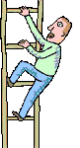  25 | 26 | 27 | 28 | 29 | 30
24 | 23 | 22 | 21 | 20 | 19
13 | 14 | 15 | 16 | 17 | 18
12 | 11 | 10 | 9 | 8 | 7
1 | 2 | 3 | 4 | 5 | 6

How do you say ‘little pig’ in German? | Where did the pigs live at the beginning of the story? | How do you say ‘a straw house’ in German?
The rabbit said “ist es stabil genug?” to the Lazy Pig. What does this mean? | The wolf was “groß und …………………? | Why did Schweinchen Faul want to use straw?
What material is a “Backsteinhaus” made out of? | What material did Schweinchen Schick use? | Where was the cooking pot placed – auf das …………………..?
Can you remember what ‘leise’ means? | What did the pigs say when the wolf knocked on the door? | Complete this sentence: „ich gehe lieber Rotkäppchen .................“
How does the wolf say “I’ve got a good idea” in German? | The wolf “hustete und pustete”. What did he do? | How do you say ‘onions’ in German?
How did the wolf describe the stew? | How do you say ‘carrots’ in German? | When the wolf says “ich werde dir dein Haus wegblasen,” what is he going to do?

Action Charades

Purpose | - to make connections  - to make decisions  - to develop listening skills  - to develop memory skills
Links to KS2 framework | - O3.2 Recognise and respond to sound patterns and words  - O3.4 Use physical response, mime and gesture to convey meaning and show understanding  - L3.1 Recognise some familiar words in written form  - L3.2 Make links between some phonemes, rhymes and spellings, and read aloud familiar words  - O4.2 Listen for specific words and phrases using physical response to show recognition and understanding  - O4.3 Listen for sounds, rhyme and rhythm
Preparation | Pupils work in groups of 3 or 4. Each group will need:  - 1 set of charade cards  It is advisable to demonstrate activity with whole class initially
Activity | - Demonstrate the first sentence by reading it out and asking pupils to suggest an appropriate mime. Practise repetition of phrase.  - Continue to read out the other sentences allowing the children to demonstrate their understanding by miming.  - Give each group a set of charade cards and ask them to place them face down on the table.  - Each pupil takes one card in turn and reads the phrase. The group mime accordingly.  - After each phrase has been mimed, repeat the previous activity but this time the pupil with the card mimes the action while the rest of the group guess the complete phrase.  - They also need to establish the character by asking “bist du Schweinchen Faul/der Wolf?” etc
Debrief | Ask pupils what they learned about the language through the process. What skills and dispositions did they use? I.e. listening, turn taking etc.

Die drei Schweinchen verlassen den Bauernhof.
Schweinchen Faul baut ein Haus aus Stroh.
Schweinchen Doof isst Gemüsesuppe.
Der Wolf klopft leise an die Tür.
Der Wolf hustet und pustet.
Der Wolf bläst das Haus einfach weg.
Der Wolf frisst Schweinchen Faul.
Schweinchen Schick baut ein Haus aus Holz.
Der Wolf klopft sehr laut an die Tür.
Der Wolf klettert in den Schornstein hinein.
Der Wolf frisst Schweinchen Schick.

Der Wolf klopft laut an die Tür.
Schweinchen Doof baut ein Haus aus Backsteinen.
Der Wolf rutscht den Schornstein herunter.
Schweinchen Doof kocht eine Gemüsesuppe.
Bernd verkauft Backsteine.
Der Wolf fällt ins heiße Wasser.
Schweinchen Doof stellt den Topf auf das Feuer.
Schweinchen Doof schneidet Karotten und Zwiebeln.
Der Wolf probiert die Suppe.
Der Wolf springt aus dem Topf.
Der Wolf läuft aus dem Haus.

Happy Families

Purpose | - to make connections  - to take turns  - to develop spontaneous talk
Links to KS2 framework | - O3.2 Recognise and respond to sound patterns and words  - L3.1 Recognise some familiar words in written form  - L3.2 Make links between some phonemes, rhymes and spellings, and read aloud familiar words  - O4.2 Listen for specific words and phrases  - L4.2 Follow a short familiar text, listening and reading at the same time  - L4.3 Read some familiar words and phrases aloud and pronounce them accurately
Preparation | Children sit in groups of 3 or 4. Each group has  - One set of cards
Activity | Cards are distributed evenly among the group – they count out cards in German as they are distributed. The aim of the game is to collect families by colour.  Taking turns one pupil asks the person next to him/her for a card that they want e.g. “ hast du die blaue Maus?”. If their neighbour has the card he has to hand it over saying “ja, ich habe es” if not “nein, ich habe es nicht.” This game is a good opportunity to get children to use der, die and das spontaneously.  Each group member takes it in turn to ask for a card.  When a pupil has collected a whole family he says “ich habe die blaue Familie.”
Debrief | Ask pupils what skills and dispositions they used during the activity. i.e. taking turns, being fair, reasoning

Schweinchen
Faul

die Kuh

das Pferd

die Schnecke

das Backsteinhaus

das Holzhaus

das Strohhaus
Schweinchen Schick

Schweinchen Doof

Schweinchen
Faul

die Kuh

das Pferd

die Schnecke

das Backsteinhaus

das Holzhaus

das Strohhaus

Schweinchen Schick

Schweinchen Doof

Schweinchen
Faul

die Kuh

das Pferd

die Schnecke

das Backsteinhaus

das Holzhaus

das Strohhaus

Schweinchen Schick

Schweinchen Doof

tit

Schweinchen
Faul

die Kuh

das Pferd

die Schnecke

das Backsteinhaus

das Holzhaus

das Strohhaus

Schweinchen Schick

Schweinchen Doof

Blockbusters

Purpose | - to make connections  - to solve problems
Links to KS2 framework | - O3.3 Perform simple communicative tasks using single words, phrases and short sentences  - O4.4 Ask and answer questions on several topics
Preparation | Pupils work in groups of 3.  One group member asks the questions, the other two play against each other. Each group will need:  - 1 blockbusters board  - 1 set of questions  Pupils must try to get from the left to the right side of the game board, by matching the revealed initials to vocabulary from the story of Die drei kleinen Schweinchen, marking their route with counters.
Activity | The Rules:  - Pupils must then choose a hexagon from the left side of the board, taking turns to play.  - After the first go, pupils can only choose hexagons that touch an answered shape.  - As the capital letters are revealed in each hexagon, the pupil must answer a matching question from the question sheet.  - If the question is answered correctly, the child can claim the shape as theirs, by putting one of their coloured counters on the shape.  - If the question is incorrectly answered the shape is left blank. The other pupil may not use that space either. (Perhaps put a black counter on the shape to remind everyone that it is out of play)
Debrief | Ask pupils what they learned and how they learned it. What skills did they use? I.e. listening, reasoning, etc. What dispositions did they need? i.e. turn taking.

S
T
F
B
H
S
H
P
K
R
S
T
B
H
R
K
S
Z
K
L
B
L
L
S
F
V
K

B What B is where a farmer lives?
B What B can be used to build houses?
B What B describes the bricks that Bernd is selling?
F What F describes the lazy pig?
F What F was used to heat the water?
H What H can be used to build houses?
H What H describes the water?
H What H is what the wolf does to try to blow the house down?
K What K gave advice to Schweinchen Faul?
K What K is an ingredient in the soup?
K What K is to knock?
K What K describes how the wolf gets to the top of the chimney?
L What L means ‘loudly’?
L What L means ‘quietly or softly’?
L What L describes the taste of the soup?
P What P is what the wolf does to try to blow the house down?
R What R describes the noise the wolf makes after eating the pigs?
R What R describes how the wolf gets down the chimney?
S What S is the pigs?
S What S did one pig use to build his house?
S What S did Schweinchen Doof make?
S What S is a usual home for a pig?
S What S describes the house made of bricks?
T What T means a cooking pot?
T What T is the normal way into a house?
V What V describes the soup?
Z What Z is a sort of vegetable used in the soup?

Narrative Format Script
Die drei kleinen Schweinchen
Teacher and class stand in a circle. The teacher leads the class through the story by saying each part in short sections with the class echoing and performing the accompanying actions. In this way all the class are engaged in activity throughout and are able to perform to their individual abilities without feeling pressurised.
Narrator hand pointing back over one shoulder, then hold up one finger, show 3 fingers, snorting action | Es waren einmal drei kleine Schweinchen.  eins, zwei, drei
N. hold up one finger and then walk fingers away into distance.  make a roof shape for house  wave | Eines Tages verlieβen sie den Bauernhof, wo sie wohnten, weil jedes Schweinchen sein eigenes schönes Haus bauen wollte.  Tralala, tralala, tralalalala  Auf Wiedersehen! Bis später!
snort + point at self  Schweinchen Faul bright idea action. | Ich bin Schweinchen Faul.  Oh! Guck mal daran!  Ich baue mir ein Haus aus Stroh. Das ist leicht!
N. smiley face action.  wolf stance  knock softly, open mouth action with hand | Also baute Schweinchen Faul ein Haus aus Stroh und war sehr froh.  Plötzlich kam ein groβer böser Wolf vorbei. Er klopfte leise an die Tür und sagte:
Der Wolf | Schweinchen klein, Schweinchen klein, lass mich herein!
Schweinchen Faul  shaking finger | Das fällt mir ja im Traum nicht ein!
Der Wolf huffing and puffing | Dann werde ich husten und pusten und dir dein Haus wegblasen.
Narrator huffing and puffing, fling arms open wide, eat pig and lick lips  wrap arms around self | Der Wolf hustete und pustete und blies das Strohhaus einfach weg. Dann fraβ er Schweinchen Faul auf! Mm lecker!  Armes Schweinchen Faul!
snort + point at self  Schweinchen Schick building house, hammering wood etc | Ich bin Schweinchen Schick.  Ich baue mir ein Haus aus Holz. Sehr praktisch!
Narrator  looking proud  wolf stance, knock loudly, open mouth action with hand | Also baute Schweinchen Schick ein Haus aus Holz und war sehr stolz darauf.  Dann kam der Wolf wieder vorbei. Er klopfte laut an die Tür und sagte:
Der Wolf | Schweinchen klein, Schweinchen klein, lass mich herein!
Schweinchen Schick shaking finger | Das fällt mir ja im Traum nicht ein!
Der Wolf huffing and puffing | Dann werde ich husten und pusten und dir dein Haus wegblasen.
Narrator huffing and puffing, fling arms open wide, eat pig and lick lips  wrap arms around self | Der Wolf hustete und pustete und hustete und pustete und blies das Holzhaus einfach weg. Dann fraβ er Schweinchen Schick auf! Mm lecker!  Armes Schweinchen Schick!

snort + point at self  Schweinchen Doof  scratching head then  penny dropping, draw brick shape in air | Ich bin Schweinchen Doof.  Woraus soll ich mir ein Haus bauen?  Na klar! .........Aus Backsteinen!
Narrator  wolf stance, knock very loudly, open mouth action with hand | Also baute Schweinchen Doof ein Haus aus Backteinen, das groβ und sehr stabil war. Fantastisch, nicht wahr! Vielleicht ist es doch nicht so doof!  Dann kam der groβe böse Wolf vorbei. Er klopfte sehr laut an die Tür und sagte:
Der Wolf | Schweinchen klein, Schweinchen klein, lass mich herein!
Schweinchen Doof  shaking finger | Das fällt mir ja im Traum nicht ein!
Der Wolf huffing and puffing | Dann werde ich husten und pusten und dir dein Haus wegblasen.
Narrator huffing and puffing repeatedly | Der Wolf hustete und pustete und hustete und pustete und HUSTETE und PUSTETE  Aber das Backsteinhaus blieb stehen.
Der Wolf bright idea look | Ich habe eine gute Idee
Narrator bright idea action, climbing, jumping down, then splash | Der Wolf hatte eine gute Idee. Er kletterte in den Schornstein hinein, rutschte den Schornstein herunter und fiel ins heiße Wasser. Platsch!
Der Wolf jumping up and down holding bottom | Aua! Das brennt!  Das reicht mir mit diesem Schweinchen!
Narrator jump out of pot and run on spot. Wave goodbye | Der Wolf sprang aus dem Topf und lief aus dem Haus.  Tschüs, Herr Wolf!

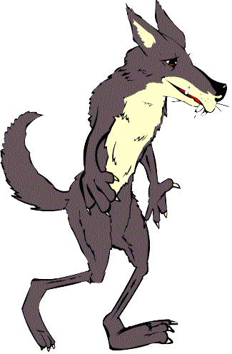

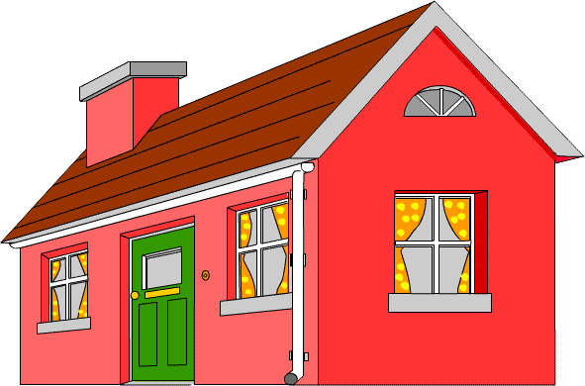
Die drei Schweinchen,
Die drei Schweinchen,
Na ja ! Na ja ! Na ja !
Die drei Schweinchen.

Sie wohnen auf dem Land,
Sie wohnen auf dem Land,
Na ja ! Na ja ! Na ja !
Sie wohnen auf dem Land.

Sie verlassen den Bauernhof,
Sie verlassen den Bauernhof,
Na ja ! Na ja ! Na ja !
Sie verlassen den Bauernhof.

Sie bauen drei Häuser
…..

Aus Stroh ist leicht,
…..

Aus Holz ist praktisch,
…..
Ein Wolf kommt vorbei,
…….

Er hustet und pustet,
……

Er bläst zwei Häuser weg
…….

Das Backsteinhaus bleibt stehen,
……

Die Suppe ist lecker,
…..

Bis später, Herr Wolf,
Bis später, Herr Wolf,
Na ja ! Na ja ! Na ja !
Bis später, Herr Wolf.

Die drei kleinen Schweinchen
((sing to tune of: ”The farmer’s in his den.”)

Board Game Language

Rules of the game | die Spielregeln
A game/a player | ein Spiel/ein Spieler
Board game | ein Brettspiel
Start (square) | Start/Anfang
Finish (square) | Ende/Ziel
A counter (etc) | eine Spielmarke
Put your counter at the start. | setz(t) deine (eure) Spielmarke(n) an den Anfang
Throw the dice. | würfle
The one (player) with the highest number starts. | Wer die höchste Zahl hat/Nummer wirft, beginnt
The one who throws a 6 starts. | Wer eine ‘6’ wirft, beginnt das Spiel
Whose turn? | Wer ist dran?/Wer ist an der Reihe?
Mine | ich bin dran
Yours | du bist dran
His | er ist dran
Hers | sie ist dran
An extra turn | du bist wieder an der Reihe
Take it in turns | wechselt euch ab
Miss a turn | setz eine Runde aus!
Go forward 5 | geh 5 vorwärts
Go forward 2 squares | geh 2 Felder vorwärts
Go back 1 square | ein Feld zurück
Go back to the start | zum Anfang zurück
Draw (i.e. no winner) | unentschieden
He/She is cheating | er/sie mogelt (er spielt falsch)
He/She’s winning | er/sie gewinnt
Who’s winning? | Wer gewinnt?
You’ve won | du hast gewonnen
I’ve won | ich habe gewonnen
I’m the winner | ich bin der Sieger/die Siegerin
the score/result | das Spielergebnis
Pick up your cards | nimm/nehmt deine/eure Karten in die Hand
I will teach you how to play | ich zeige dir/euch, wie man spielt
Pack of cards | ein Kartenspiel
Pick a card | nimm eine Karte/wähl eine Karte
Shuffle the cards | die Karten mischen
I pass (i.e. I’m stuck/ I can’t play) | ich passe
I give in | ich gebe auf
Get in teams of 2, or 3 etc | Mach Mannschaften von 2 oder 3  tue dich mit 2 anderen zusammen
Choose a team | wähl eine Mannschaft aus
Let’s play again. | sollen wir noch mal spielen?

MFL KS2 Framework for year 4

 | Oracy |  | Literacy |  | Intercultural Understanding | Knowledge about Language | Language Learning Strategies
O4.1 | To memorise and recite a short text  - Learn finger rhymes, poems or short stories or a non-fiction text | L4.1 | To read and understand a range of familiar written phrases  - Match phrases and short sentences to picture or topics | IU4.1 | To learn about festivals and celebrations in different cultures  - Learn how children of different cultures celebrate special days  - Identify similarities and differences  - Learn simple phrases to celebrate festivals | Reinforce and extend recognition of word classes and understand their function  Recognise and apply simple agreements, singular and plural  Apply question forms  Develop awareness of communication strategies  Recognise that texts in different languages will often have the same conventions of style and layout  Apply phonic knowledge of the foreign language to support reading and writing  Identify a different writing system | Discuss language learning and reflect and share ideas and experiences  Use actions and rhymes to aid memorisation  Ask for repetition and clarification  Use context and previous knowledge to help understanding  Practice new language – speaking aloud or silently, speaking with a friend  Practice new language outside the classroom  Plan and prepare for a language activity  Read and memorise words  Use a mental association to help remember words  Sort words into categories  Apply knowledge about letters and simple grammatical knowledge to experiment  Use context and previous knowledge to determine meaning and pronunciation
O4.2 | To listen for specific words and phrases in a song, poem or story  - Listen with care  - Use physical response to show recognition and understanding of key words and phrases  - Look carefully at the person who is speaking | L4.2 | To follow a short familiar text, listening and reading at the same time and them read part of the text aloud  - Make links between the spoken and written words  - Identify common spelling patterns in letter strings  - Pronounce letter strings, words and phrases accurately with good accent | IC4.2 | To know about some aspects of everyday culture and compare them to their own:  - To learn and compare pastimes of children of different cultures
O4.3 | To listen for sounds, rhyme and rhythm | L4.3 | To read some familiar words and phrases aloud and pronounce them accurately  - Use words which they practice on a regular basis, e.g. numbers, days, weather | IU4.3 | To compare traditional stories  - Compare characteristics of simple stories between cultures  - Learn about aspects of the writing system of a different language
O4.4 | To ask and answer questions on several topics  - Ask how to say something in the target language  - Ask someone to clarify or repeat  - Speak clearly and confidently | L4.4 | To write simple words and phrases using a model and some words from memory | IU4.4 | To learn about ways of travelling to the target country / countries  - Revise location of country / countries where target language is spoken  - Identify route from own locality to specified destination

MFL KS2 Framework for year 3

 | Oracy |  | Literacy |  | Intercultural Understanding | Knowledge about Language | Language Learning Strategies
O3.1 | To listen and respond to simple stories, finger rhymes and songs  - Identify rhyming words  - Perform finger rhymes and sing songs  - Listen to stories  - Join in with storytelling | L3.1 | To recognise some familiar words in written form  - Understand words displayed in the classroom  - Identify and read short simple words when listening to familiar rhymes or stories or songs  - Read short messages | IU3.1 | To learn about the different languages spoken by children in the school  - Be aware of linguistic and cultural diversity | Identify specific sounds, phonemes and words, linking sounds to meanings  Imitate pronunciation of sounds  Hear main word classes  Recognise questions and negatives  Recognise how sounds are represented in written form  Notice the spelling of familiar words  Recognise that languages describe familiar things differently  Recognise the centrality of language in communication  Recognise different language conventions to express politeness | Discuss language learning and reflect and share ideas and experiences  Use actions and rhymes to aid memorisation  Ask for repetition and clarification  Use context and previous knowledge to help understanding  Practise new language – speaking aloud or silently, speaking with a friend  Practise new language outside the classroom  Look at the face of the person speaking and listen attentively  Use gestures and mime to show understanding  Play games to help memorisation  Recognise words which the teacher mouths silently
O3.2 | To recognise and respond to sound patterns and words  - Listen with care  - Identify sounds which are the same as or different from English  - Speak clearly and confidently | L3.2 | To make links between some sounds, rhymes and spellings and read aloud familiar words  - Identify characters and letter strings which are the same as or different to English  - Pronounce accurately the most commonly used characters and letter strings  - Read aloud a familiar sentence, rhyme or poem | IC3.2 | To locate country / countries where the language to be studied is spoken:  - Identify some of the countries where the language is spoken  - Know some facts about one country where the target language is spoken, e.g. climate, main towns, famous landmarks, produce
O3.3 | To perform simple communicative tasks using single words, phrases and short sentences  - Remember, retain and recall vocabulary  - Ask and answer questions | L3.3 | To experiment with the writing of short words  - Copy simple, familiar words using a model  - Write some single words from memory | IU3.3 | To identify social conventions at home and in other cultures  - Learn about polite forms of address  - Know how to greet native speakers  - Know some typical names
O3.4 | To listen attentively and understand instructions, everyday classroom language and praise words  - Repeat words and phrases spoken by the teacher  - Develop speaking strategies such as mime and gesture to convey meaning.  - remember a sequence of spoken words  - Use physical response to show understanding |  |  | IU3.4 | To make indirect or direct contact with country / countries of target language

